**Alekhya Krishna Balivada Azure Databricks Assignment -5 (03-01-2024)**

|  |  |
| --- | --- |
| Name | Alekhya Krishna Balivada |
| Date | 03-01-2024 |
| Type | Daily Assignment |
| Topic | Creating storage account and connecting storage account with Storage Explorer |

**Data Lake:** Azure Data Lake is also a cloud-based storage which enables the users to store the vast amount of data. Azure Data Lake Storage (ADLS) is the primary storage component within Azure Data Lake.

**Azure Account Storage:** Azure Account is a cloud-based storage to store different kinds of big data. We can store the data in different storages like Blob storage, File storage, Queue storage, Table storage and Disk storage.

**Creating Storage Account in Microsoft Azure Account:**

**Step-1:** Login to the Microsoft Azure account and search for the storage account and click on create to create the storage account.

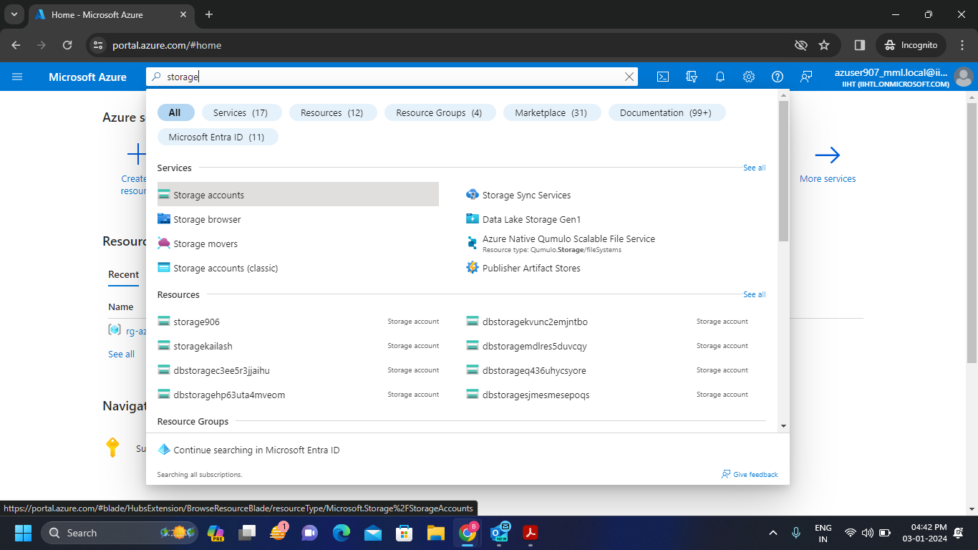

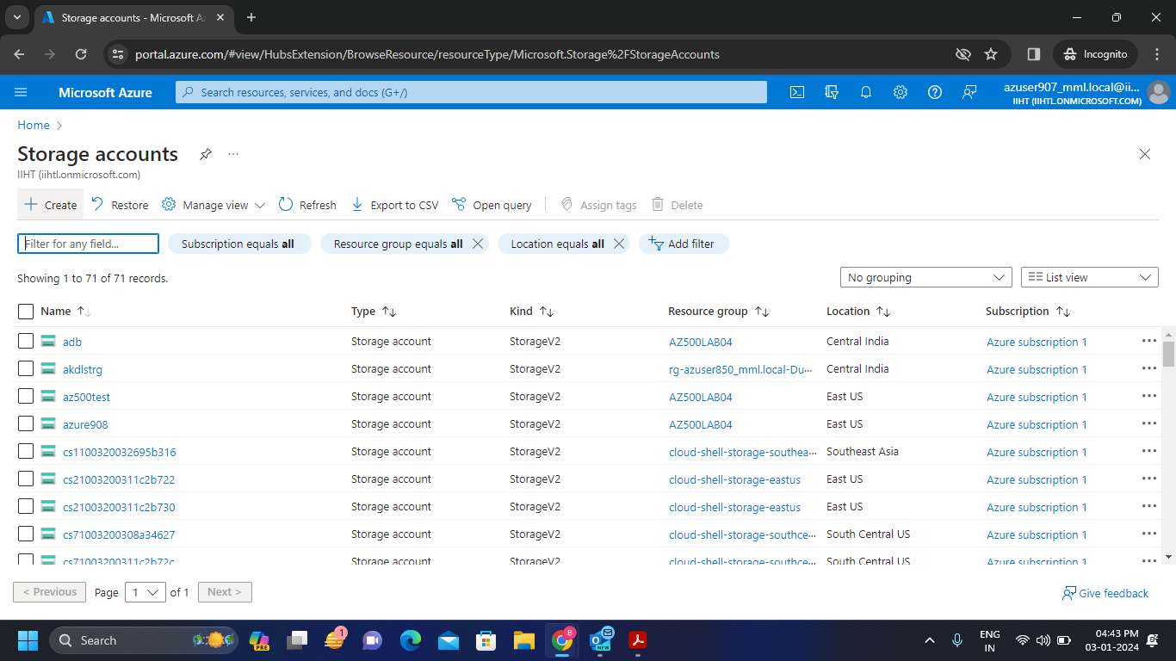

**Step-2:** Fill the required details and link with the resource group which is linked with your user credentials. And in advanced section enable the Hierarchical namespace. Finally review and create the storage account.

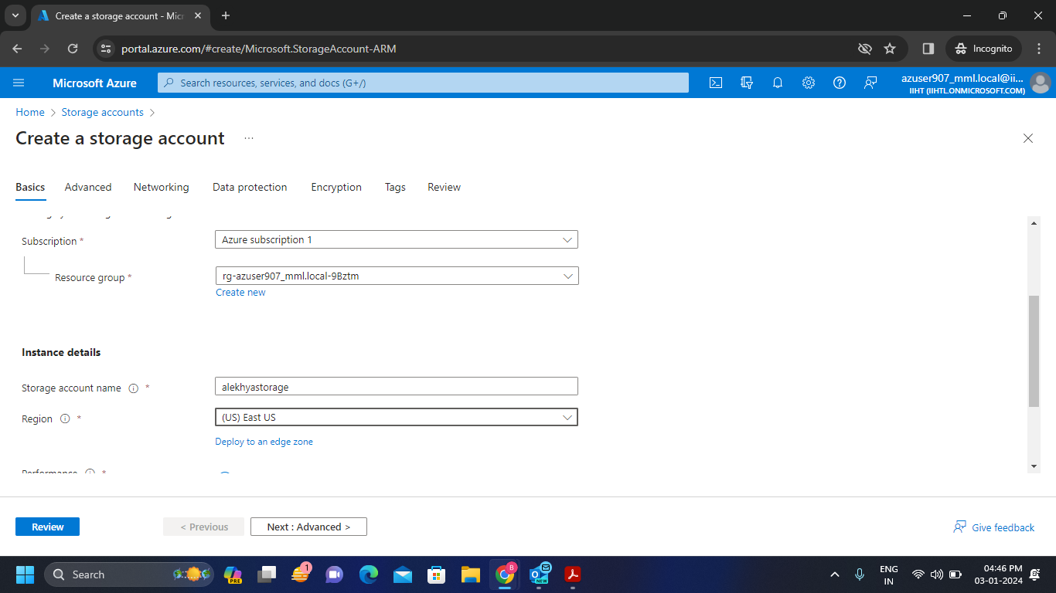

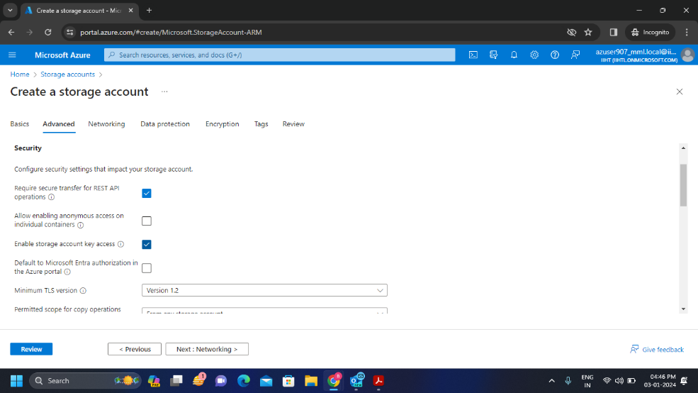

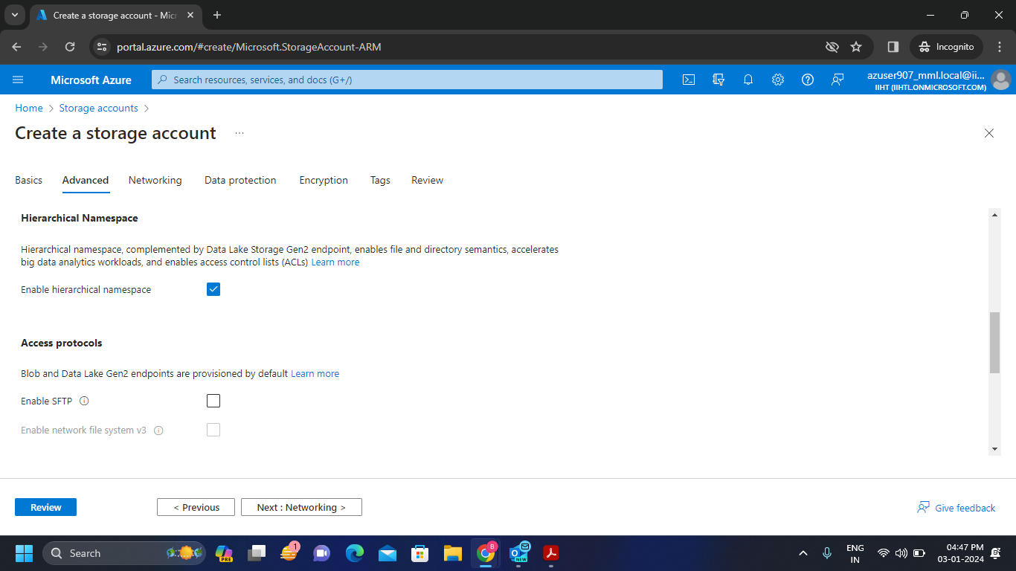

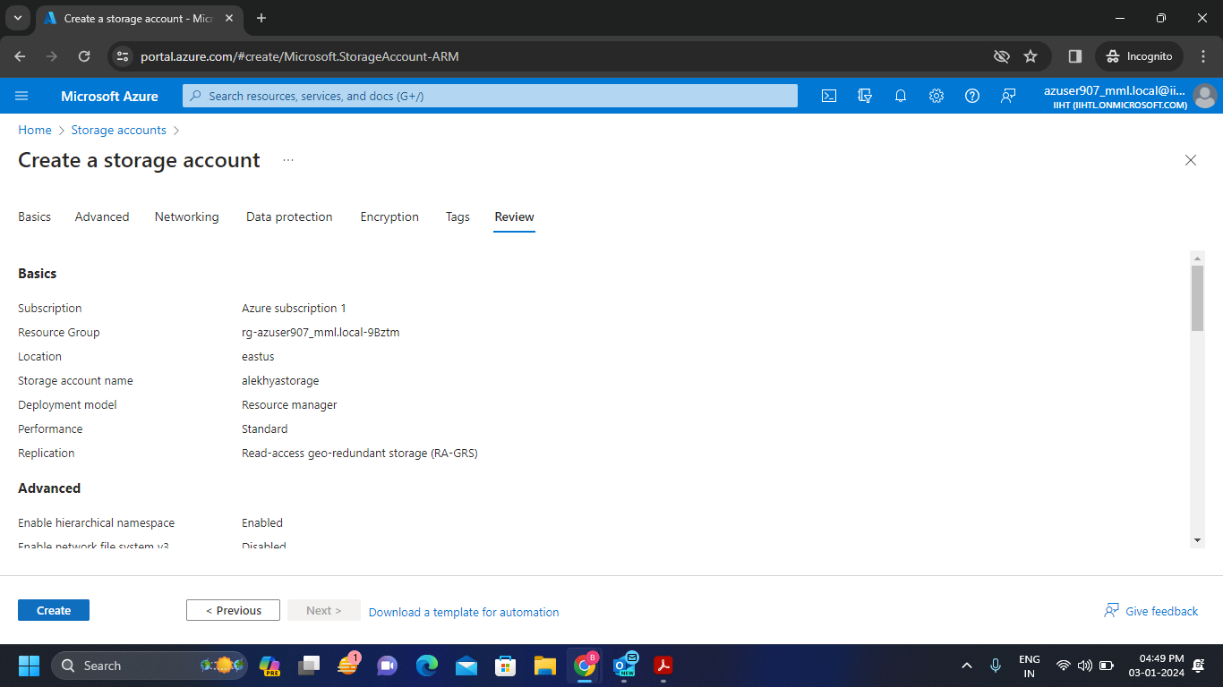

**Step-3:** It will show the process of Deployment and will get the deployment complete status after the completion of deployment.

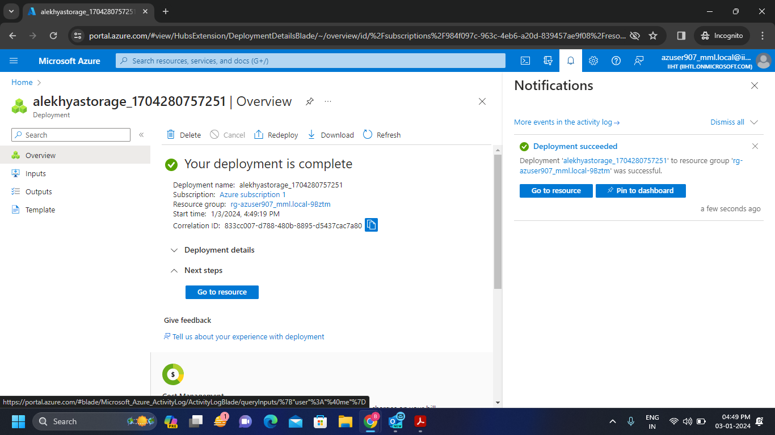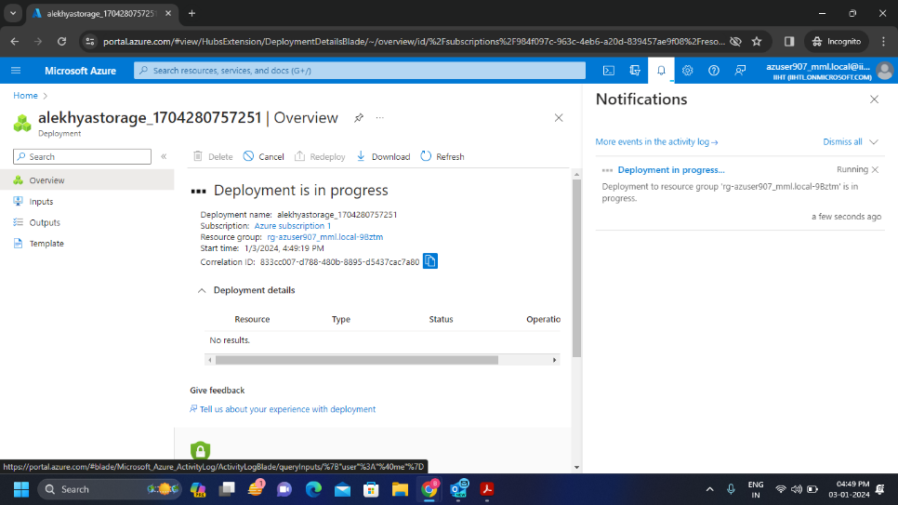

**Connecting Microsoft Azure Storage Account with Microsoft Azure Storage Explorer:**

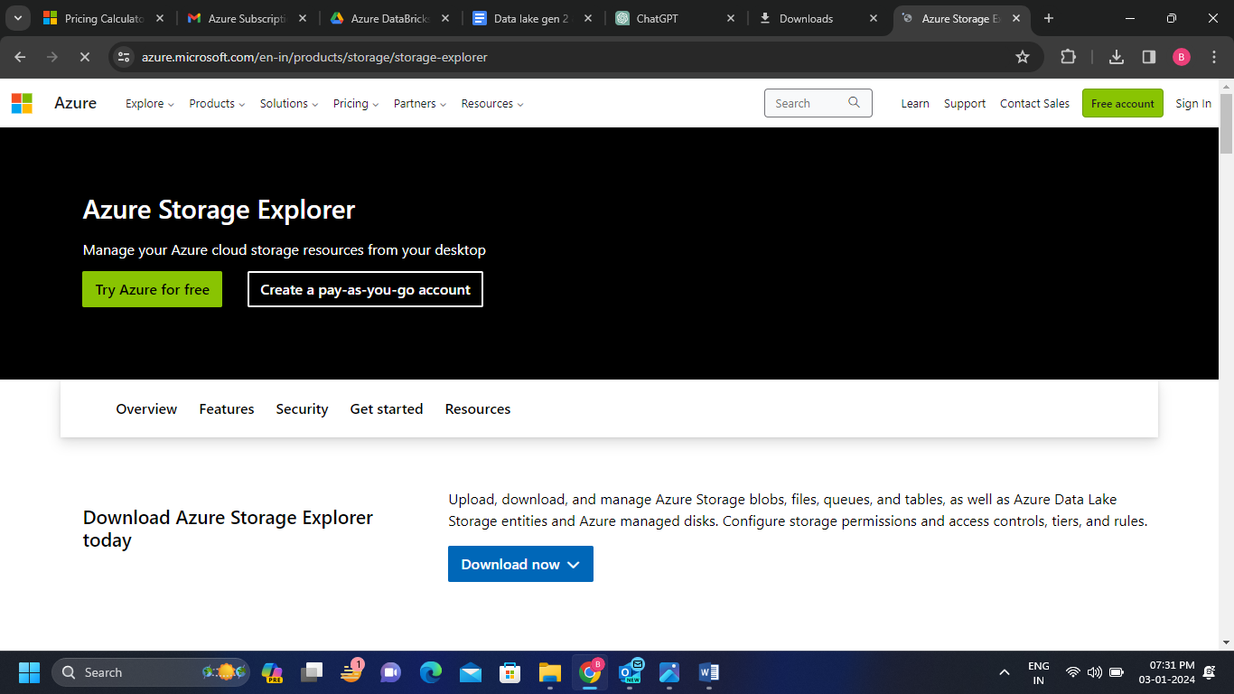**Step-1:** Download the Azure Storage Explorer and install it in the local system.

**Step-2:** Sign in with your azure account and login with the user ID and temporary access pass.

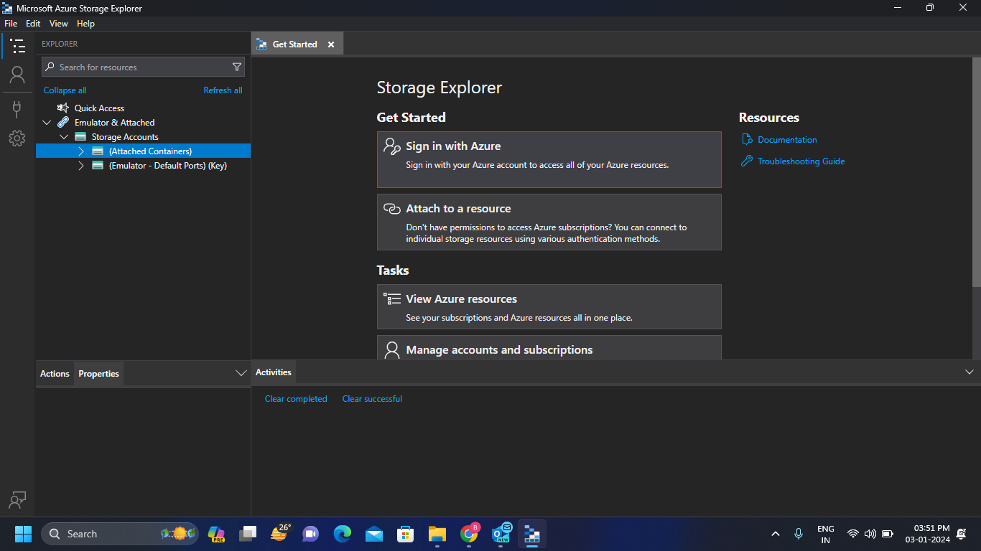

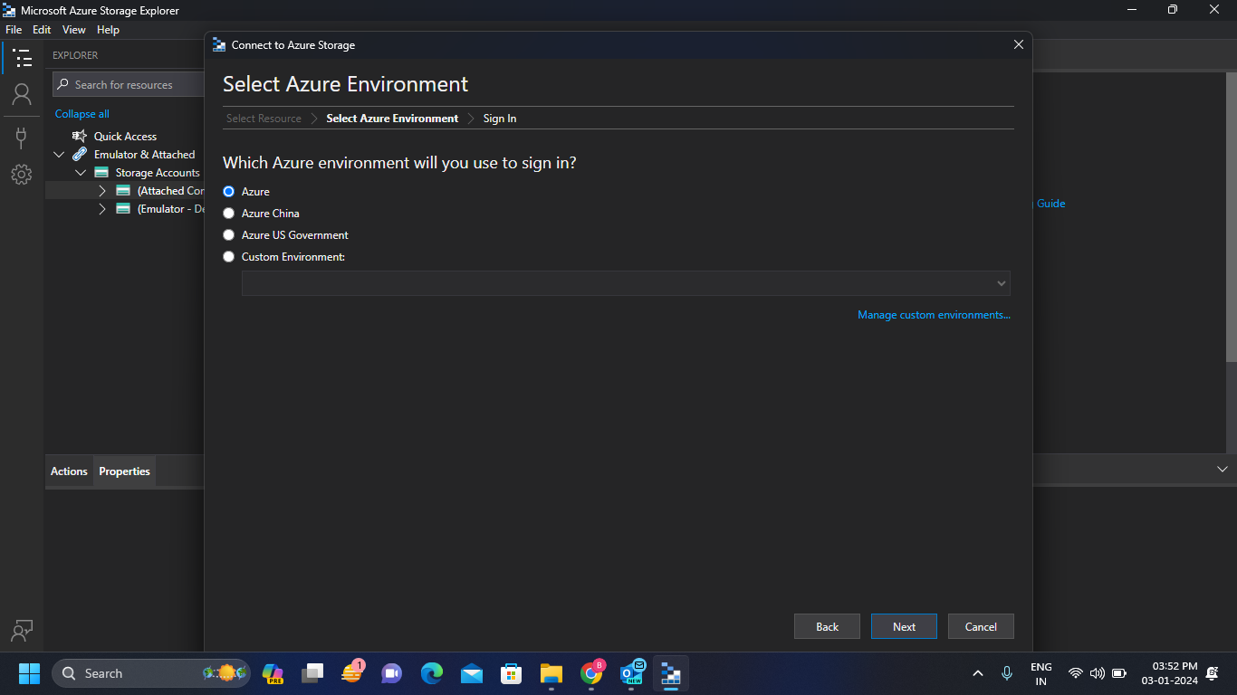

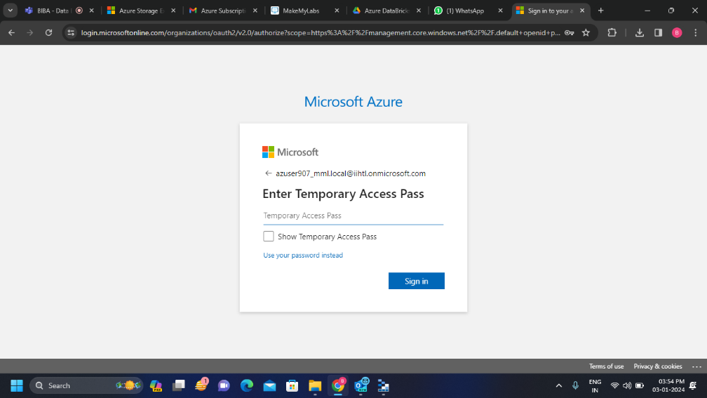

**Step-3:** After signing in we will direct to the following window. Make sure that we do not close that window to run the storage account in storage explorer.

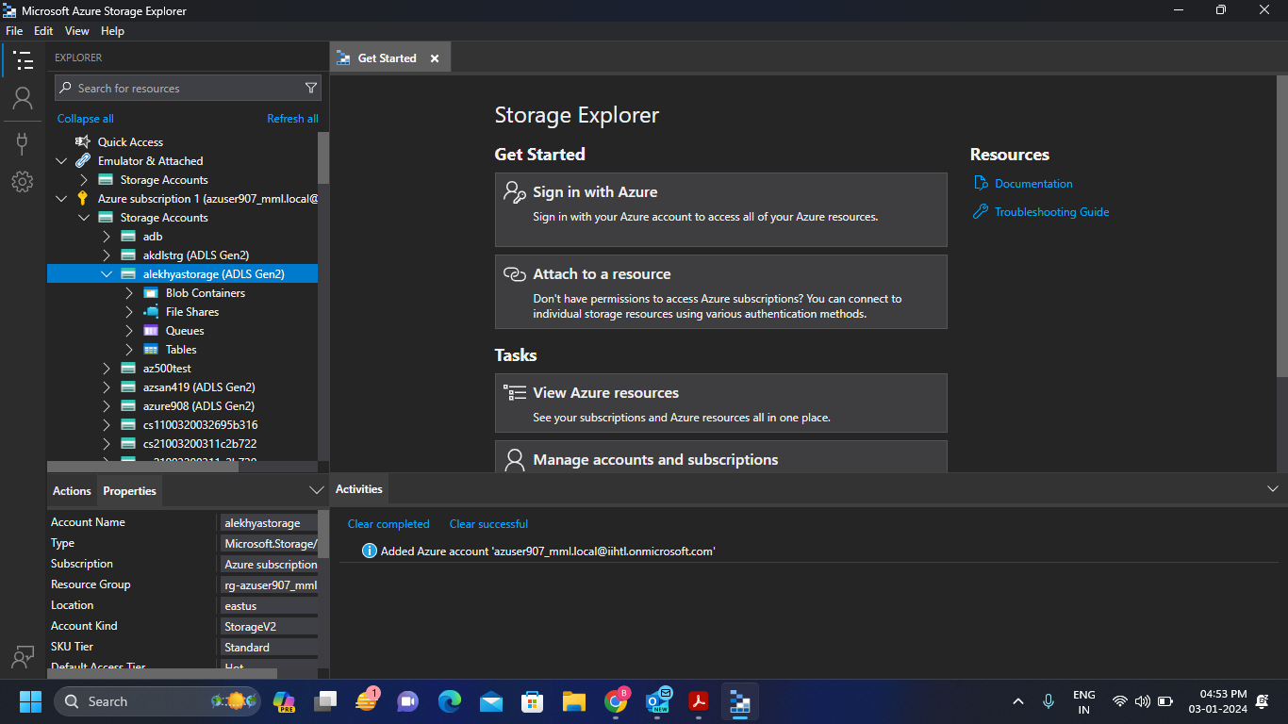**Step-4:** Successfully we connected our Microsoft Azure Storage Account with Microsoft Azure Storage Explorer. Now on the left side we can see our created storage account.

* 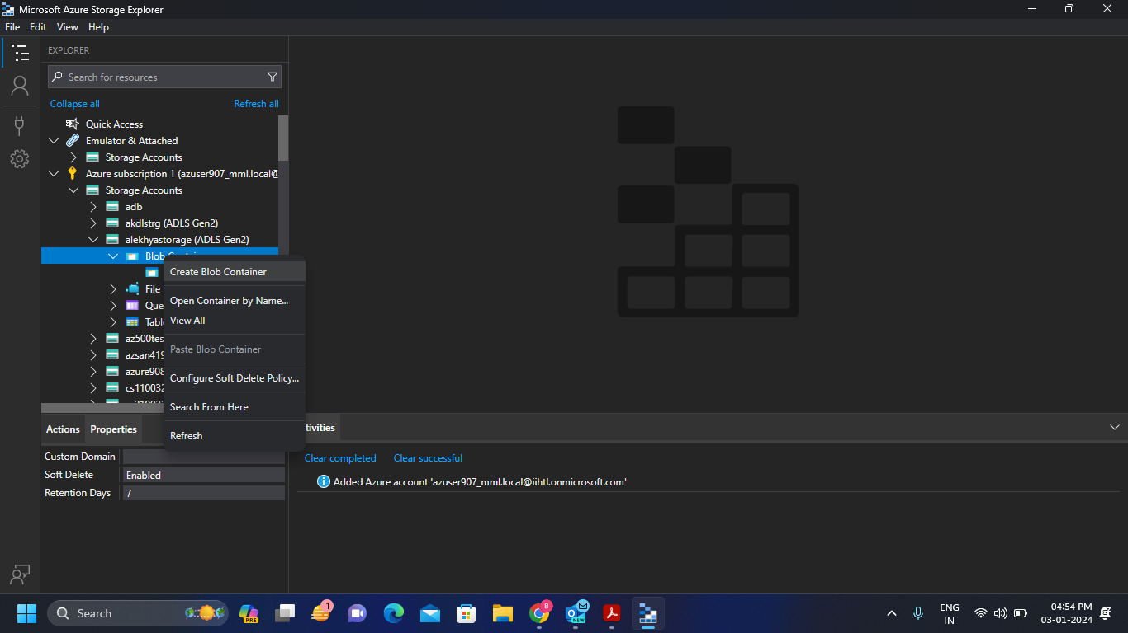Now click on Blob container to upload the files inside it.

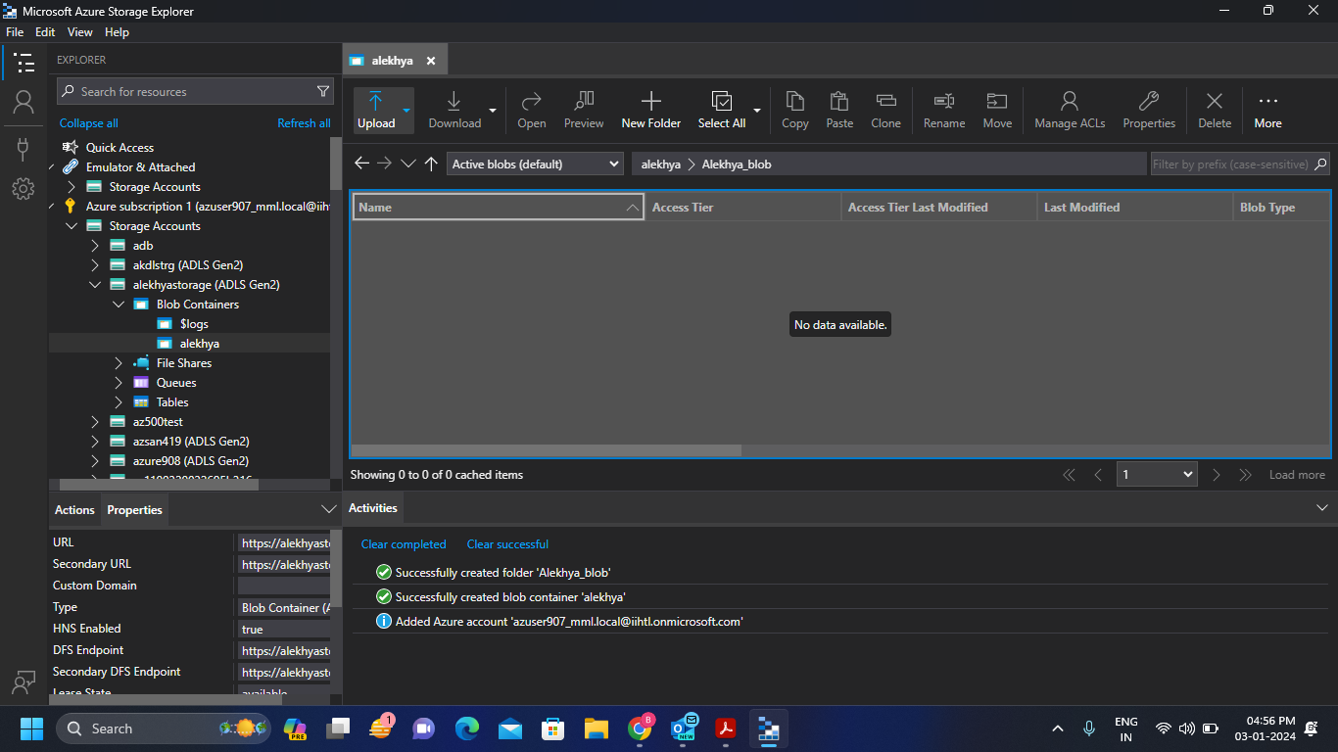**Step-5:**  Now click on new folder to create a folder and click on upload to upload a folder or file inside the Blob container. We can see whether the process is succeeded or not in the below activities window.

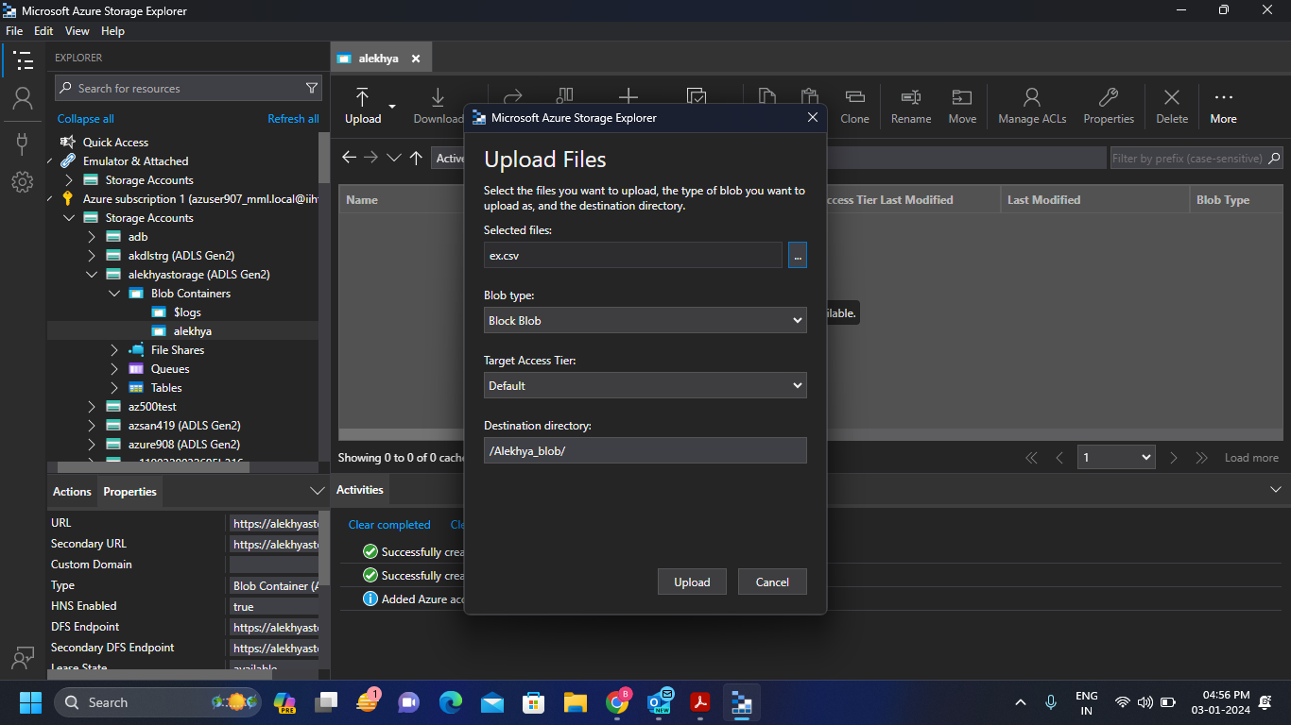

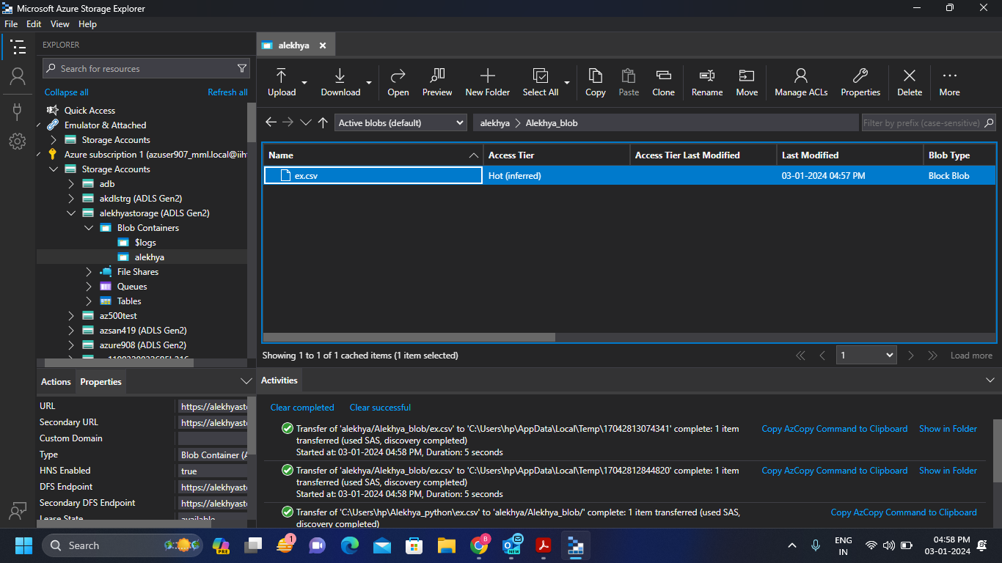

**Step-6: 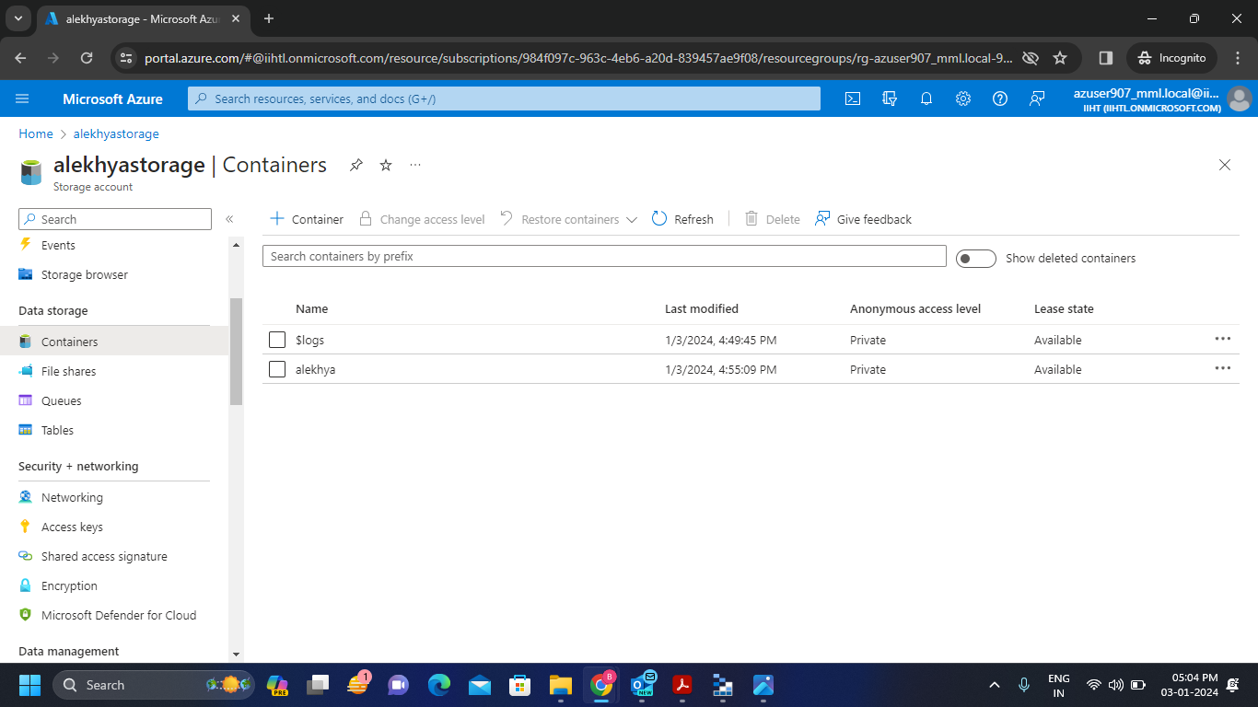**We can see our Blob Storage file in the container in the Microsoft Azure storage Account.